ASSIGNMENT-6
NAME:D SRI RAGHAV SECTION: A
USN: ENG24CY0095 ROLL NO: 16

- Which command is used to list the contents of a directory? Justify with proper example

We can use the ls command lists all files and directories in the current working directory.

ls -l: long listing (permissions, owner, size, date)
ls -a: shows hidden files (starting with.)
Example:
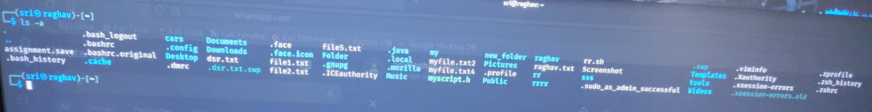

- Write the command to create a new directory named 123test_dir

We can use the mkdir (make directory) command creates a new directory.
After running it, a new folder named 123test_dir will appear in your current location.
Example:
The command is:
mkdir 123test_dir
This makes a new folder with that name in the current location. If you want to create multiple nested directories at once (like abc/xyz), you add -p:
mkdir -p abc/xyz
That way you don’t get errors if the parent directory doesn’t exist.

- What is the purpose of the sed command? Justify with proper example
sed stands for Stream Editor. It processes text line by line and can perform operations like find-and-replace, deletion, insertion, or printing. It’s super useful for quickly editing text in files without opening them manually.
Example:
Replace all occurrences of “Linux” with “Unix” in file.txt:
sed 's/Linux/Unix/g' file.txt
Here s means substitute, and g means “replace globally in each line.”
Another example: Delete line 3 from a file:
sed '3d' file.txt
So, sed is basically like a robot editor—you tell it the rule, and it applies it automatically across the file.

- Which distinct command is used to display one-line descriptions of any commands
The distinct command used to display one-line descriptions of commands in Linux is

Whatis

whatis <command> shows a brief description of the command.
It looks up the man (manual) page database and displays a single line summary

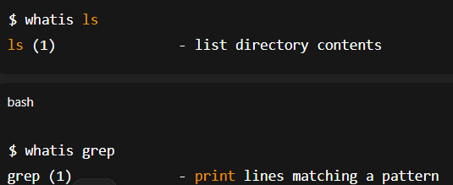

5. Write the command to create an empty file named “notes.txt”
To create an empty file named notes.txt in Linux, you can use the touch command:

touch : creates a new empty file if it does not exist.
If notes.txt already exists, touch updates its timestamp without modifying content.

6. Differentiate between grep and awk commands with an example.
grep Command
Purpose:
- Searches for patterns or strings in a file or input.
- Outputs matching lines only.
- Simple and fast for pattern matching

grep [options] pattern filename

example:
Suppose file.txt contains:

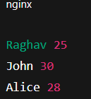

To search for lines containing "John"
Output:

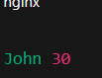

awk Command
Purpose:
- A powerful text processing tool.
- Can search patterns, extract fields, perform calculations, and format output.
- More advanced than grep for structured data.

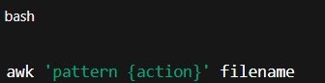

Example:
To print the name (1st field) of people older than 27 in file.txt:
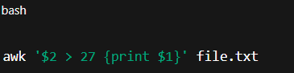

Output
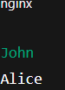
3. Key Differences
Feature | grep | awk
Function | Searches for patterns/strings | Searches, extracts fields, and processes data
Complexity | Simple | Advanced
Field/Column Handling | No | Yes
Arithmetic Operations | No | Yes
Output | Matching lines | Customizable output

7.Write the command to give read, write, and execute permission to the owner of a file script.sh
. Write the command to give read, write, and execute permission to the owner of a file script.sh
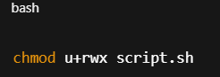
chmod → command to change file permissions.
u → stands for user/owner of the file.
+rwx → adds read (r), write (w), and execute (x) permissions.
script.sh → the target file.

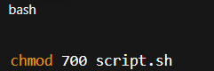

7 → owner gets rwx
0 → group gets no permission
0 → others get no permission
8. How is chown different from chgrp? Give one example for each
Feature | chown | chgrp
Changes | Owner (and optionally group) | Only group
Requires sudo? | Yes, for changing others’ files | Yes, for changing group if not your own
Example | chown raghav file.txt | chgrp developers file.txt
chown Command
Purpose:
- Changes the owner of a file or directory.
- Can also change both owner and group at the same time.
Syntax:
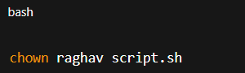
Example:

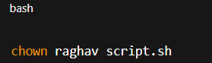

Explanation:
- Changes the owner of script.sh to raghav.
- Group remains unchanged.
Optional: Change owner and group together
chgrp Command
Purpose:
- Changes only the group ownership of a file or directory.
Syntax:
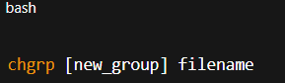
Example:
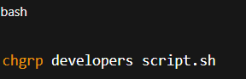
9. A user complains that they cannot execute a file even though it exists in their directory. How would you troubleshoot this using ls -l, chmod, and whoami
Here’s a step-by-step approach to troubleshoot why a user cannot execute a file in their directory using ls -l, chmod, and whoami
Step 1: Check File Permissions with ls -l
Run:
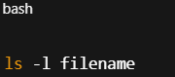
Example Output:
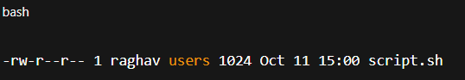
Interpretation:
- The first part -rw-r--r-- shows permissions:
  - r → read
  - w → write
  - x → execute
- The owner is raghav, group is users.
- Here, the file does not have execute (x) permission for anyone, so it cannot be executed.
- Step 2: Identify the Current User with whoami
- Run:
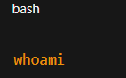

Example Output:
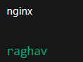
Confirms which user is trying to execute the file.
Compare with the owner/group from ls -l.
Step 3: Grant Execute Permission Using chmod
- If the user is the owner, grant execute permission:
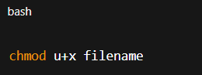
- u+x → adds execute permission for the owner.
- If you want everyone to execute:
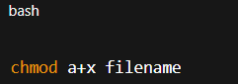
a+x → adds execute permission for all users (owner, group, others).
Step 4: Verify Permissions Again
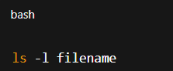
Example Updated Output:
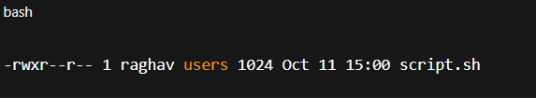
Now, the owner raghav can execute the file.
Run it
10. Design a command pipeline to: find all .log files modified in the last 2 days in /var/log, display them on screen, and save the results into a file recent_logs.txt using tee command
You can achieve this in Linux using a command pipeline with find and tee. Here’s how:
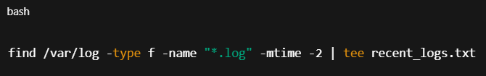
find /var/log → Start searching in /var/log.
type f → Restrict search to files only.
name "*.log" → Match files ending with .log.
mtime -2 → Find files modified in the last 2 days.
- -mtime n → exactly n days old
- -mtime -n → modified less than n days ago
Pipe the output of find to the next command.
tee recent_logs.txt →
- Displays the output on the screen.
- Saves a copy to recent_logs.txt.
find /var/log -type f -name "*.log" -mtime -2 -exec ls -l {} \; | tee recent_logs.txt

